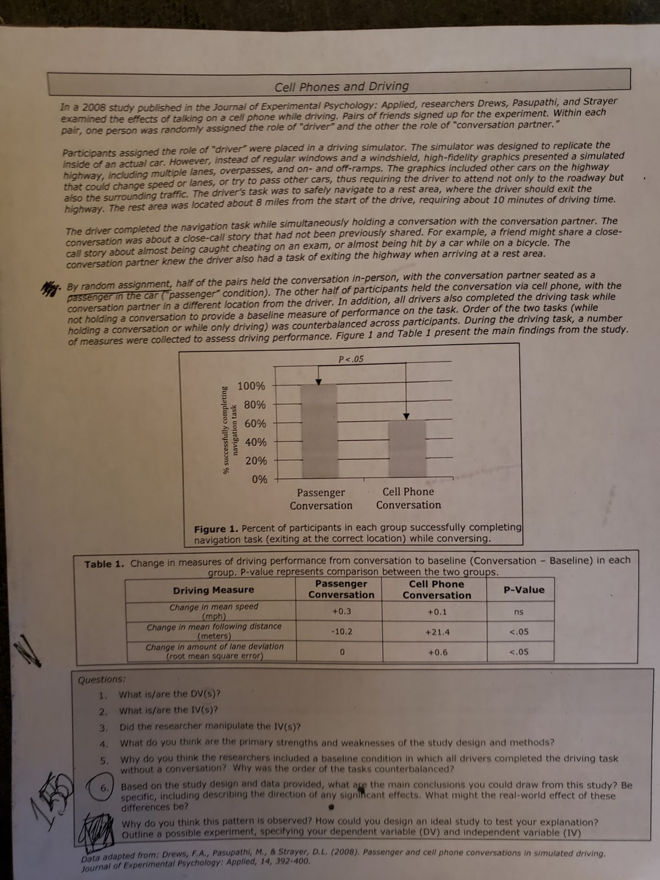

PSY 108 Reflection & Application Paper:
Participating in Research/Research Ethics

Prompt #2: Reflecting on the research ethics of a real-world study

For this prompt, choose a study that we have discussed in class (Cell phone while driving). You will describe and explain the study in detail, so that a person unfamiliar with the study would read your paper and get a clear understanding of the methods and results of the study, and reflect on the ethics of that study.

When you write your Reflection & Appplication paper, make sure you discuss the following:

- Discuss the ethics of human subjects research, being sure to describe and explain concepts discussed in class. In your discussion, you should define and explain the concepts of informed consent and debriefing. Why are these concepts important when designing psychological research?
- Describe the study you have chosen in detail. Make sure you are writing like an expert, as if you are teaching someone else about this study. What were the researchers studying? What did they do, and what did they find?
- Imagine what it was like to be a participant in this study. Do you think you would have been comfortable or uncomfortable participating in this study? Why or why not? What could researchers do to address any ethical concerns or set participants at ease? What information do you think participants should have been provided at debrief? Be specific, and explain your thinking.

- Your final paper should be 2-3 pages, double-spaced
- You should write as if you are the expert, explaining concepts and describing your experiences to an audience that is not familiar with these concepts. Think of someone you know who is intelligent, but doesn’t know a lot about psychology, and imagine you are writing this paper to teach them about psychology and its application to the real world.
- You will be evaluated based on your ability to clearly explain the psychological concepts that you are discussing, the depth of your discussion about how these concepts apply to the real world. Use of appropriate language, spelling/grammar, and proofreading will also be considered when evaluating your paper.

